**Advance Database Management System Lab**

**Experiment- 1**

**To understand DDL and DML commands**

**Aryan Mohan**

**500092142**

**Batch- 2**

create database LabExperiment1;

use LabExperiment1;

CREATE TABLE CLIENT_MASTER(CLIENTNO VARCHAR(6), NAME VARCHAR (20), ADDRESS1 VARCHAR(30), ADDRESS2 VARCHAR(30), CITY VARCHAR(15), PINCODE INT, STATE VARCHAR(15), BALDUE DECIMAL(10,2));

CREATE TABLE PRODUCT_MASTER (PRODUCTNO VARCHAR(6), DESCRIPTION VARCHAR(15), PROFITPERCENT DECIMAL(4,2), UNIT_MEASURE VARCHAR(10), QTYONHAND INT, REORDERLVL INT, SELLPRICE DECIMAL(8,2), COSTPRICE DECIMAL(8,2));

CREATE TABLE SALESMAN_MASTER (SALESMANNO VARCHAR(6), SALESMANNAME VARCHAR(20), ADDRESS1 VARCHAR(30), ADDRESS2 VARCHAR(30), CITY VARCHAR(20), PINCODE INTEGER, STATE VARCHAR(20), SALAMT REAL, TGTTOGET DECIMAL(10,2), YTDSALES DECIMAL(6,2), REMARKS VARCHAR(60), PRIMARY KEY (SALESMANNO));

INSERT INTO CLIENT_MASTER VALUES ('C00001', 'Ivan Bayross', '','', 'Mumbai', 400054, 'Maharashtra', 15000.00);

INSERT INTO CLIENT_MASTER VALUES ('C00002', 'Mamta Muzumdar', '','', 'Madras', 780001, 'Tamil Nadu', 0.00);

INSERT INTO CLIENT_MASTER VALUES ('C00003', 'Chhaya Bankar', '','', 'Mumbai', 400057, 'Maharashtra', 5000.00);

INSERT INTO CLIENT_MASTER VALUES ('C00004', 'Ashwini Joshi', '','', 'Bangalore', 560001, 'Karnataka', 0.00);

INSERT INTO CLIENT_MASTER VALUES ('C00005', 'Hansel Colaco', '','', 'Mumbai', 400060, 'Maharashtra', 2000.00);

INSERT INTO CLIENT_MASTER VALUES ('C00006', 'Deepak Sharma', '','','Bangalore', 560050, 'Karnataka', 0.00);

INSERT INTO PRODUCT_MASTER VALUES ('P00001','T-Shirts', 5.00, 'Piece', 200, 50, 350.00, 250.00);

INSERT INTO PRODUCT_MASTER VALUES ('P0345','Shirts', 6.00, 'Piece', 150, 50, 500.00, 350.00);

INSERT INTO PRODUCT_MASTER VALUES ('P06734','Cotton Jeans', 5.00, 'Piece', 100, 20, 600.00, 450.00);

INSERT INTO PRODUCT_MASTER VALUES ('P07865','Jeans', 5.00, 'Piece', 100, 20, 750.00, 500.00);

INSERT INTO PRODUCT_MASTER VALUES ('P07868','Trousers', 2.00, 'Piece', 150, 50, 850.00, 550.00);

INSERT INTO PRODUCT_MASTER VALUES ('P07885','Pull Overs', 2.500, 'Piece', 150, 50, 850.00, 550.00);

INSERT INTO PRODUCT_MASTER VALUES ('P07868','Denim Shirts', 4.00, 'Piece', 100, 40, 350.00, 250.00);

INSERT INTO PRODUCT_MASTER VALUES ('P07868','Lycra Tops', 5.00, 'Piece', 70, 30, 300.00, 175.00);

INSERT INTO PRODUCT_MASTER VALUES ('P07868','Skirts', 5.00, 'Piece', 75, 30, 450.00, 300.00);

INSERT INTO SALESMAN_MASTER VALUES ('S00001','Aman','A/14','Worli','Mumbai',400002,'Maharashtra',3000,100,50,'Good');

INSERT INTO SALESMAN_MASTER VALUES ('S00002','Omkar','65','Nariman','Mumbai',400001,'Maharashtra',3000,200,100,'Good');

INSERT INTO SALESMAN_MASTER VALUES ('S00003','Raj','P-7','Bandra','Mumbai',400032,'Maharashtra',3000,200,100,'Good');

INSERT INTO SALESMAN_MASTER VALUES ('S00004','Ashish','A/5','Juhu','Mumbai',400044,'Maharashtra',3500,200,150,'Good');

--Find out the names of all the clients.

SELECT NAME FROM CLIENT_MASTER;

OUTPUT:

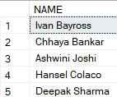

--Retrieve the entire contents of the Client_Master table.

SELECT * FROM CLIENT_MASTER;

OUTPUT:

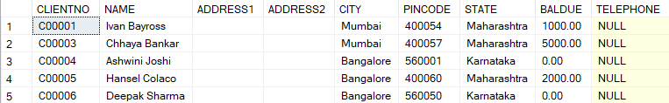

--Retrieve the list of names, city and the state of all the clients.

SELECT NAME, CITY, STATE FROM CLIENT_MASTER;

OUTPUT:

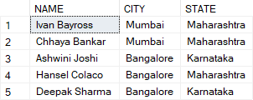

--List the various products available from the Product_Master table.

SELECT PRODUCTNO, DESCRIPTION FROM PRODUCT_MASTER;

OUTPUT:

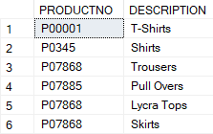

--List all the clients who are located in Mumbai.

SELECT CLIENTNO, NAME FROM CLIENT_MASTER WHERE CITY = 'Mumbai';

OUTPUT:



--Find the names of salesman who have a salary equal to Rs.3000

SELECT SALESMANNAME FROM SALESMAN_MASTER WHERE SALAMT = 3000;

OUTPUT:

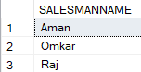

--Change the city of ClientNo ‘C00005’ to ‘Bangalore’.

UPDATE CLIENT_MASTER SET CITY = 'Bangalore' WHERE CLIENTNO = 'C00005';

OUTPUT:

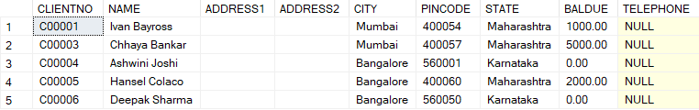

--Change the BalDue of ClientNo ‘C00001’ to Rs.1000.

UPDATE CLIENT_MASTER SET BALDUE = 1000 WHERE CLIENTNO = 'C00001';

OUTPUT:

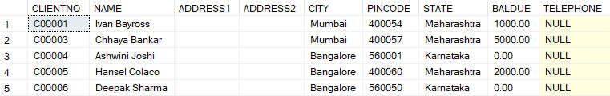

--Change the cost price of ‘Trousers’ to rs.950.00.

UPDATE PRODUCT_MASTER SET COSTPRICE = 950.00 WHERE DESCRIPTION = 'Trousers';

OUTPUT:

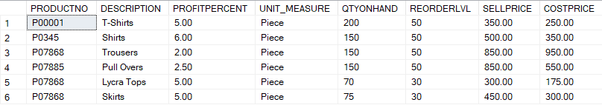

--Change the city of the salesman to Pune.

UPDATE SALESMAN_MASTER SET CITY = 'Pune';

OUTPUT:



--Delete all salesman from the Salesman_Master whose salaries are equal to Rs.3500.

DELETE FROM SALESMAN_MASTER WHERE SALAMT = 3500;

OUTPUT:



--Delete all products from Product_Master where the quantity on hand is equal to 100

DELETE FROM PRODUCT_MASTER WHERE QTYONHAND = 100;

OUTPUT:

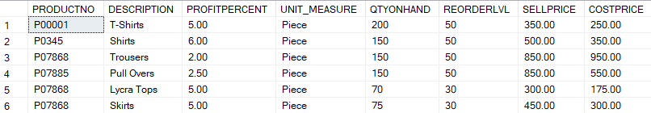

--Delete from Client_Master where the column state holds the value ‘Tamil Nadu’.

DELETE FROM CLIENT_MASTER WHERE STATE = 'Tamil Nadu';

OUTPUT:

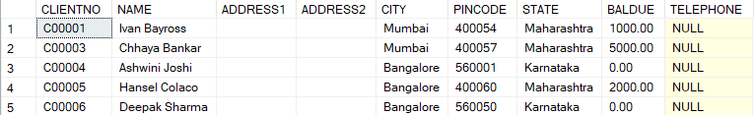

--Add a column called ‘Telephone’ of data type integer to the Client_Master table.

ALTER TABLE CLIENT_MASTER ADD TELEPHONE INT;

OUTPUT:



--Change the size off SellPrice column in Product _Master to 10, 2.

ALTER TABLE PRODUCT_MASTER ALTER COLUMN SELLPRICE DECIMAL(10,2);

OUTPUT:

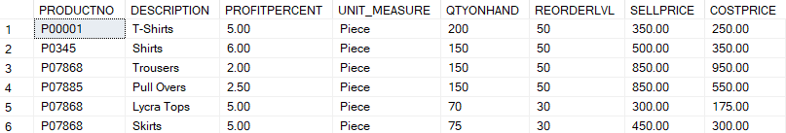

--Destroy the table Client_Master along with its data.

DROP TABLE CLIENT_MASTER;

--Change the name of the Salesman_Master to sman_mast.

ALTER TABLE SALESMAN_MASTER RENAME to sman_mast;

SELECT * FROM sman_mast;

OUTPUT:

